
Walton County Sheriff’s Office
MICHAEL A. ADKINSON, JR., SHERIFF
__________________________________________________________________________________________

Covid-19
Severe Acute Respiratory Syndrome - Coronavirus Infectious Disease – 2019

Agency Response Plan

Prepared by: COVID-19: Incident Management Team - Planning Section

Contents
Background 5
General Guidelines for All Divisions 6
Employee Temperature Monitoring 9
Facemasks 10
Employee Suspected Exposures 11
Disinfecting Law Enforcement Vehicles 13
Disinfecting Communal Workspaces 14
Phase I 15
Patrol Division 15
Training Division 17
Criminal Investigations Bureau 17
School Resource Deputies 18
Corrections Division 18
Child Protection Unit 22
Animal Control 22
Courthouse Deputies 24
Communications 24
Administration 24
Fire Rescue 25
Phase II 33
Patrol Division 33
Training Division 33
Criminal Investigations Bureau 33
Corrections Division 34
Child Protective Unit 34
Animal Control 34
Courthouse Deputies 34
Communications 34
Administration 34
Fire Rescue 35
Critical Staffing Levels 36
Patrol Division 36
Training Division 36
Criminal Investigations Division 36
Corrections Division 36
Child Protective Unit 36
Animal Control 36
Courthouse 37
Communications 37
Fire Rescue 38
Resources 49
Phase I Organization Chart
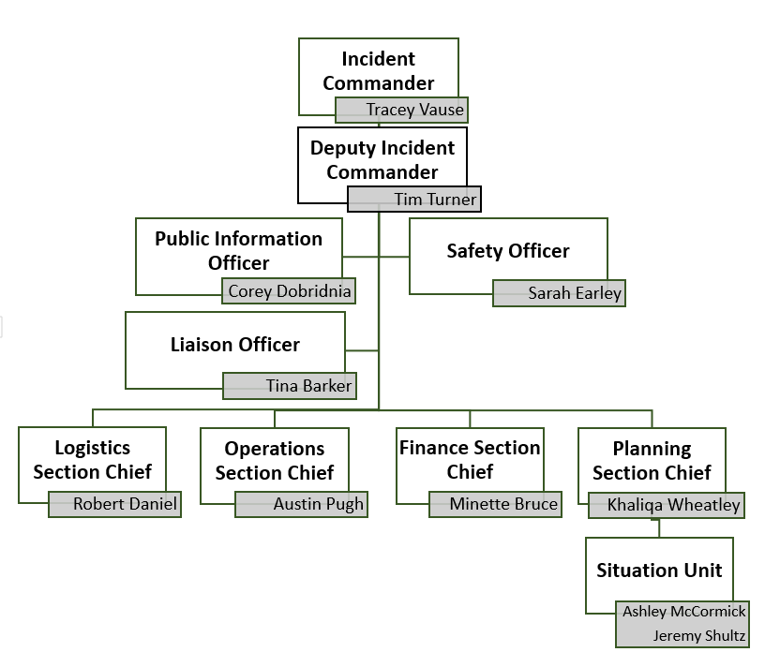

For all additional questions or concerns that haven’t been addressed within this Response Plan, follow the instructions below for guidance.

WCSO Internal Information Hotline: (850) 951-7008 ext. 0430

After Hours – Use the Chain of Command as listed below

Medical Questions/Concerns: Lt. Jonathan Davis (850) 401-9505
Fire Questions/Concerns: Chief James McMillan (850) 598-4714
LEO/Corrections/Communications/Animal Control: Capt. Dustin Burlison (850) 419-3241
COVID-19 Employee Screening Questions/Concerns: Lt. Rich Allison (850) 520-3784
Background

This plan will outline the readiness and potential response activities to patients potentially having the virus named “SARS-CoV-2” and the disease it causes; “coronavirus disease 2019” (abbreviated “COVID-19”).

Mode of transmission: Early reports suggest person-to-person transmission most commonly happens during close exposure to a person infected with COVID-19, primarily via respiratory droplets produced when the infected person coughs or sneezes. Droplets can land in the mouths, noses, or eyes of people who are nearby or possibly be inhaled into the lungs of those within close proximity. The contribution of small respirable particles, sometimes called aerosols or droplet nuclei, to close proximity transmission is currently uncertain. However, airborne transmission from person-to-person over long distances is unlikely.

General Guidelines for All Divisions

- All staff that are planning on traveling should review and follow CDC travel guidance which can be found at https://www.cdc.gov/travel.
- All staff that develop fever or respiratory symptoms or concerns of exposure to COVID-19, should report to their supervisor prior to returning to work. The supervisor will then obtain direction from the Incident Management Team (IMT).
  - Symptoms or concerns developing during the shift should be reported to the supervisor immediately and direction sought from the IMT.
  - Symptoms or concerns developing after hours should be reported to the supervisor. The supervisor will immediately contact Lt. Sarah Earley for guidance (850) 420-6783.
- Maintain safe distance in all contacts when possible (6 feet)
- Effective immediately all members of the public entering any Walton County Sheriff’s Office location including the Animal Shelter, Jail, Fire Stations, and Administrative Offices will be required to wear a mask or facial covering. If they do not have one, one will be supplied to them.
- Staff who receive visitors or come in contact with the public at any Sheriff’s Office location are encouraged to wear facial coverings
- Avoid enclosed spaces when dealing with the public (try to speak to people outside)
- No leave will be given without prior approval of the Division’s respective Bureau Chief
- Morning meetings and other large briefings should be suspended or done in a digital environment to avoid exposing the entire Command Staff at once.
- Ensure facility policies and practices are in place to minimize exposures to respiratory pathogens including SARS-CoV-2, the virus that causes COVID-19. Syndromic Surveillance at the 911 Communications Center shall be implemented before Fire, EMS, or Law Enforcement resources are dispatched to a potentially infected patient, maintained upon arrival and throughout the duration of contact with the patient
- Code 19 on the radio will be used to refer to suspected (Per Deputy Response Guide Questions) or confirmed cases of COVID-19
- Contact or exposure
  - Exposure will be determined when a Deputy or Staff member comes into contact with someone who meets the criteria on the Deputy Response Guide Questions AND the subject is displaying symptoms AND the Deputy or Staff member is not using PPE
- Facemasks
  - Wear a mask, if you are coughing or sneezing.
  - If you are healthy, you only need to wear a mask if you are taking care of a person suspected with COVID-19.
  - Face masks are only effective when used in combination with proper hand-washing techniques.
- The COVID-19 virus should be handled professionally when spoken about to the public and not made “light” of.
- All training classes out of town are canceled
- Fire, EMS and Law Enforcement personnel must take steps to ensure all persons with symptoms of COVID-19 or other respiratory infection (e.g., fever, cough) adhere to respiratory hygiene, cough etiquette (place mask on patient), and hand hygiene throughout the duration of the contact.

Adhere to Standard and Transmission-Based Precautions
- Standard Precautions assume that every person is potentially infected or colonized with a pathogen that could be transmitted in the healthcare setting. Elements of Standard Precautions that apply to patients with respiratory infections, including COVID-19, are summarized below.
- Evaluate the need for and provide training on proper donning (putting on), doffing (taking off), and disposal of any PPE.

Hand Hygiene
  - Responders should perform hand hygiene before and after all patient contact, contact with potentially infectious material, and before putting on and after removing PPE, including gloves.
  - Responders should perform hand hygiene by using an alcohol-based hand rub (ABHR) with 60-95% alcohol or washing hands with soap and water for at least 20 seconds.
    - If hands are visibly soiled, use soap and water before returning to ABHR.
    - If soap and water are not readily available and illicit drugs are not suspected to be present, use an alcohol-based hand sanitizer with at least 60% alcohol.

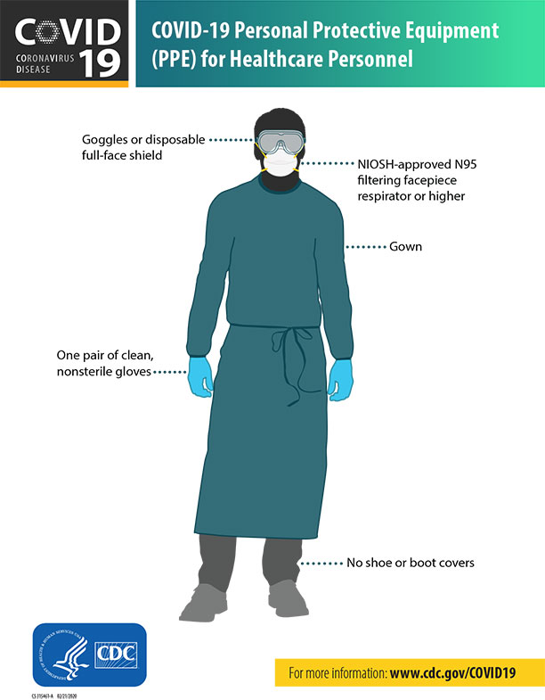
Personal Protective Equipment
  - WCSO will select appropriate PPE and provide it to responders in accordance with OSHA, CDC, and Florida DOH recommendations. Responders must receive training on:
    - When to use PPE
    - What PPE is necessary
    - How to properly don, use, and doff PPE in a manner to prevent self-contamination
    - How to properly dispose of or disinfect and maintain PPE
    - The limitations of PPE.
    - Respirator or Facemask (N-95 or surgical mask)
    - Eye Protection
    - Gloves
    - Gowns

Establish Reporting within and between Healthcare Facilities and to Public Health Authorities
- Implement mechanisms and policies that promote situational awareness for facility staff including infection control, healthcare epidemiology, facility leadership, occupational health, clinical laboratory, and frontline staff about known or suspected COVID-19 patients and facility plans for response.
- Communicate and collaborate with public health authorities.
  - Facilities should designate specific persons within the healthcare facility who are responsible for communication with public health officials and dissemination of information to HCP.
- Communicate information about known or suspected COVID-19 patients to appropriate personnel before transferring them to other departments in the facility (e.g., radiology) and to other healthcare facilities.

EMPLOYEE TEMPERATURE MONITORING
- Each employee will be responsible for self-temperature monitoring prior to beginning their shift.
- The thermometers will be placed at the following locations for use. Personal thermometers are not to be used.
  - North End Patrol Room
  - WCSO Jail Main Lobby
  - Paxton Substation
  - DeFuniak Springs Substation
  - EOC/Bunker
  - DeFuniak Springs Courthouse
  - Mossy Head Substation
  - Freeport Substation
  - South End Substation
  - CIB Conference Table
- Thermometers are to be properly disinfected by each employee prior to and after use.
- The employee is responsible for logging their daily temperatures into the digital tracker.
- Employees are to notify chain of command if the recorded temperature is 100.4°F or greater.

Disinfection Procedures
- Thermometers are always to be stored in appropriate storage container.
- Prior to using the thermometer, employees should disinfect the device, using the designated disinfectant wipes provided by the agency.
- Once the device has been disinfected, allow 1-2 minutes for the thermometer to properly air dry prior to use.
- After temperature assessment, follow above disinfectant procedure again prior to placing the thermometer back in the appropriate storage container.

FACEMASKS
- All Sheriff’s Office employees are issued black Microbe Safety Masks (MSMs)
Application of Microbe Safety Masks
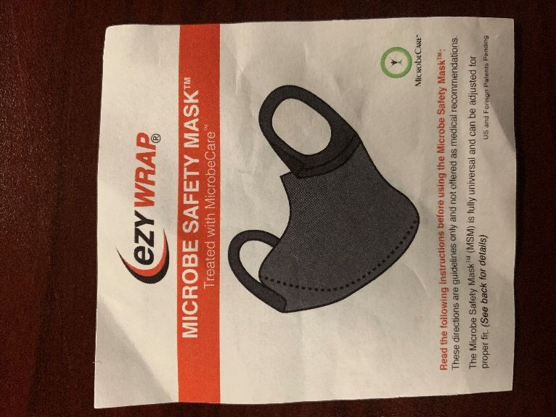
  - Hold the mask over your nose and chin, fuzzy side out
  - Pull the ear straps over each ear
  - Mask fit should be snug, yet comfortable
  - Adjust sizing as needed by removing the Velcro earpiece portion
  - For a more snug fit, move the ear pieces closer together (Note- the ear pieces can be angled).
  - Trim excess fabric if necessary
- CDC now recommends that you voluntarily wear a face mask when you are in public
- Deputies in the field are encouraged to wear face coverings when unable to maintain social distancing or are in a confined space without a barrier.
- For medical personnel, you are to wear the N95 mask as directed anytime you are providing patient care to any suspected or confirmed case, or in close proximity to the patient.
- MSM should be washed at least once daily when used, gently hand washed with warm water (NOT HOT) and a mild detergent. Rinse thoroughly. Lay flat to dry. Do not machine wash or machine dry.
- If needed, you may wear a disposable surgical mask while the MSM is drying.
- Face masks are only effective when used in combination with proper hand-washing techniques.
Fire Rescue
Fire Rescue Division employees may wear the Microbe Safety Masks in place of disposable surgical masks as PPE. These are not to be worn when providing patient care to a suspected or positive COVID19 patient. For these patients, those providing care and are in close proximity to the patient will only use the N95 mask.

EMPLOYEE SUSPECTED OR CONFIRMED CASES

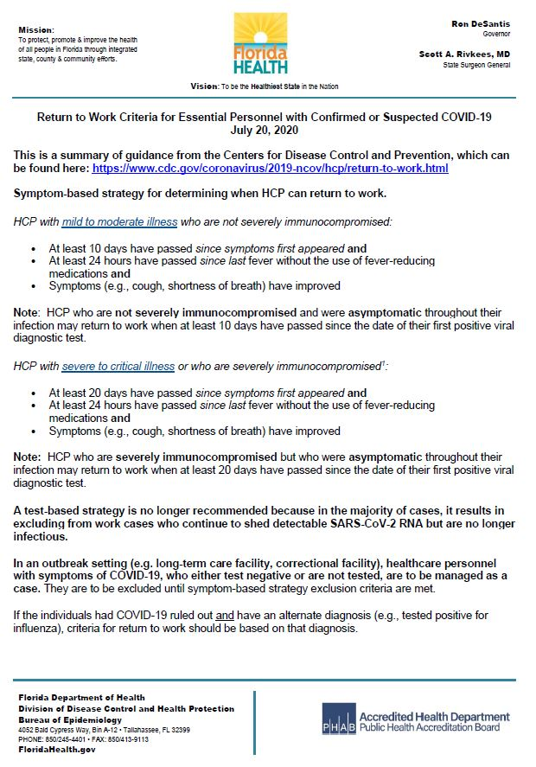
This will serve as a guideline to support workforce health and staffing. If an agency member tests positive for COVID-19, they must notify their supervisor who will notify the Incident Management Team.

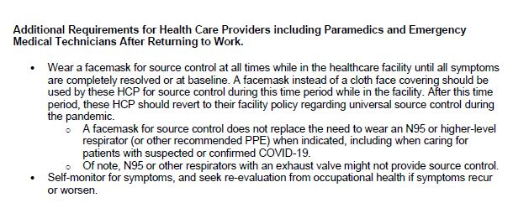
DISINFECTING AGENCY VEHICLES
Decontamination Procedures for ambulances, engines, jail transport vehicles, patrol vehicles, and work stations utilizing the HVLP sprayer (ICS 214 form/information must be completed):

- Don the following PPE:
  - Gloves
  - Face mask (Black Face Mask)
- Before disinfecting with sprayer, clean any surfaces with visible contaminants (blood, secretions, etc.)
- Pour cleaning solution into the container on the sprayer
- Connect the air hose to HVLP sprayer & SCBA
- Open SCBA bottle or turn on the compressor
- Dial regulator on the spray gun to 50 psi
- Starting at the front of the patient compartment, nearest the cab, hold the sprayer 12 to 18” from the ​surface, squeeze the trigger while moving sprayer in a side to side/up and down motion covering all surfaces from top to bottom. Pay attention to high touch areas such as:
  - Workbenches/surfaces
  - Rails
  - Control panels & switches
  - Seats, seatbelts, & buckles
  - Floors, walls, & cabinets
  - Medical bags
  - Areas surrounding medical waste bins & sharps
- After working your way back out of the back doors, be sure to spray door handles, both inside the patient compartment & outside the box
- Leave doors open for 10 minutes to give the cleaning solution time to dry
- Spray stretcher while outside of the ambulance & raised to its highest position, including the undercarriage
- Once all surfaces are dry, you are clear to return to service
Decontamination sprayers can be found at the following locations:
- Walton County Fire Rescue Station 1: 113 Webster Lane, Paxton, FL 32538
- Walton County Fire Rescue Station 3: 32 Tim Padgett Way (Formerly Collingsworth Road), Westville, FL 32464
- Walton County Fire Rescue Station 4: 49 South Davis Lane, DeFuniak Springs, FL 32435
- Walton County Fire Rescue Station 8: 7900 State Highway 81 South, Ponce De Leon, FL 32455
- Walton County Fire Rescue Station 10: 13837 State Highway 20 West, Niceville, FL 32578
- Walton County Fire Rescue Station 1101: 1235 Co Highway 1087, DeFuniak Springs, FL 32433
- Walton County Fire Rescue Station 12: 100 Washington Street, Freeport, FL 32439
- Walton County Jail Sally Port: 796 Triple G Road, DeFuniak Springs, FL 32433
- Walton County Sheriff’s Office South Substation: 133 Sheriff Drive, Santa Rosa Beach, FL 32459

DISINFECTING COMMUNAL WORKSPACES
General office cleaning should be done once a day with an approved EPA disinfectant such as "Lysol" on hard surfaces such as:
- Trash office and replace liners daily
- Disinfect desk surfaces
- Disinfect computer keyboards and electronic equipment by spraying disinfectant on a towel wipe surfaces.
- Disinfect all light switches
- Disinfect chairs
- Disinfect doorknobs
- Door jambs
- Hard floors are to be mopped every day
- Carpets are to vacuumed every day
- During the day, a light second cleaning/disinfection of the following:
  - Keyboards/Mice
  - Light switches
  - Phones
  - Chairs
Restrooms:
- Disinfect all surfaces
- Disinfect commodes
- Showers disinfected daily
- Supply restroom with a paper towel
- Supply with hand soap
Gym
- Before starting and after your workout wipe all gym machines down with approved disinfectant.
- The gym is to be mopped daily with a disinfectant mop solution

Please remember that the surface should be allowed to air dry for the disinfectant to work. Do not wipe up the damp surface with a dry towel.

Phase I – Initial Preparedness

Phase I will be initiated immediately to limit exposure of Sheriff’s Office Personnel and to maintain a high level of readiness.

Patrol Division
- PPE Kits are to be issued to all Deputies along with training guidelines on proper caution to be taken.
  - Deputies shall at a minimum wear disposable gloves on all contacts with the public.
  - Deputies shall wear their issued Microbe Safety Mask when responding to medical calls.
  - No personal leather/’stick-proof’/’cut resistant’ gloves can be used, unless the disposable glove can safely go over the personal gloves
  - When the possibility of COVID-19 is suspected/confirmed deputies will don all required components within PPE kit.
  - Disinfect back (cage) of patrol vehicles after transport of all subjects:
    - Cleaning stations will be located at the jail.
  - Do not transport public when not required.
  - Deputies should bring extra uniforms in case of contamination with blood or other bodily fluids. – Red bags are available for contaminated clothing or items and are to be disposed of at Fire Stations 4 (49 South Davis Ln, DeFuniak Springs) and 12 (100 Washington St, Freeport)
  - Uniforms do not need to be placed in red bags if exposed to only COVID-19
  - COVID-19 exposed uniforms can be placed in brown paper bags and laundered as usual
  - South Substation will provide fingerprinting for statutorily mandated requirements only
  - The North and South Walton County Sheriff’s Office gyms are open to only Walton County Sheriff’s Office employees. This restricts family members, City Employees, County workers, etc.
  - Depositions with the Public Defender can be completed by phone. Call (850) 892-8090.
  - Ride-Along program is suspended until further notice

Arrests
  - Deputies must fill out pre-arrest screening sheet prior to transportation of detainees to jail. If COVID-19 is suspected, Deputies shall:
    - The air conditioning must be on and the windows vented during transport to circulate the air flow.
    - Contact the jail in advance to let them know of possible COVID-19 symptoms
    - Upon arrival at the jail Deputies shall:
      - Follow all Jail Directions given by Jail staff on procedures
      - Submit to a temperature screening before entering the Booking Area
      - Give the pre-arrest screening information to the Jail Health Specialist (Nurse)
  - If a detainee shows symptoms of COVID-19 and meets the criteria on the pre-arrest screening sheet, a surgical mask must be placed on the detainee.
  - Notify on-duty Sergeant of possible COVID-19 case to respond and issue one additional mask for detainee to be transported
  - NTA’s will be issued in lieu of physical arrests during spring break operations as well as for other offenses when possible.
  - Minimize arrests for misdemeanors where you have discretion.
  - Any use of the Intoxilyzer will be at the guidelines of CMI (Statement from CMI in light of COVID-19)

Baker Acts
  - Deputies shall still transport Baker Act patients to Fort Walton Beach Medical Center but should ask provided screening questions prior to transport
  - Deputies shall call Fort Walton Beach Medical Center (850-862-1111) in advance, to advise them of a Baker Act patient who is suspected to have COVID-19.
  - Deputies should respond with fewest number of deputies possible to non-emergency calls.

CODE 19 Screening Implementation
  - CODE 19 will be used on the radio to identify suspected (Per Deputy Response Guide Questions) or confirmed COVID-19 cases.
  - Deputies shall stop self-dispatching to all calls for service to allow dispatch time to determine the danger of possible exposure. If a positive case is determined while on scene by Emergency Medical Services Staff members, the Sheriff’s Deputies will not respond unless requested to by medical.
  - Dispatch will advise Deputies of possible symptoms of COVID-19 when possible prior to arrival on scene
  - Deputies can advise dispatch of a CODE 19 when they ask Deputy Response Guide Questions to subject and they determine a subject meets criteria for a suspected case of COVID-19.
  - Deputies should use the COVID-19 Deputy Response Guide to make a recommendation on self-quarantine.
  - If the subject meets the criteria, the Deputy must fill out an Alert Request on Sharepoint for the subject, to send to Dispatch and recommend to the subject that they self-quarantine.
  - If Medical does not respond to the scene, the Deputy should contact the health department to report the possible case 850-892-8015 (Dept. Of Health Screening Center)
  - Limited Response to medical calls at the request of EMS (life threatening only) or at the discretion of their supervisor.
- The COVID-19 virus should be handled professionally when spoken about with the public
- Medical advice should not be given:
  - Referrals for specific medical inquiries should be to their doctor, the CDC website, and Department of Health

Training Division
- Trainees will still function in a patrol capacity with their Field Training Officers
- Follow the same precautions taken as Patrol Division

Criminal Investigations Bureau
- Investigators shall attempt to conduct interviews over the telephone instead of in-person
- Prior to conducting Death Investigations with COVID-19 symptoms, Investigators shall contact the Health Department for guidance
- Callouts to scene will be evaluated on a case by case basis by the CIB Supervisor

School Resource Deputies
- School Resource Deputies will supplement Patrol as directed until school resumes
- Once school resumes, further guidance will be provided on precautions to take
Corrections Division
  - If a detainee is brought in by a Walton County Sheriff’s Office Deputy, the Deputy and detainee will be stopped in the vestibule, between the sally port and the jail facility. Detention Deputy will meet the Patrol Deputy in the sally port or vestibule and will begin the secondary assessment. If COVID-19 is suspected and the detainee has not already been given a surgical mask, place a surgical mask on the detainee prior to continuing the screening.
  - If a detainee is brought in by an outside law enforcement agency, the pre-assessment will be completed by Detention Deputy
  - Medical staff will be contacted if detainee answers ‘YES’ to any pre-screening questions and/or temperature above 100.4°F
  - Personal protective equipment will be worn during the pre-screening until it is determined that the arrestee has not met risk factor criteria.
    - Individuals with recent travel to exposed areas or in contact with someone who has traveled to exposed areas will be placed in droplet precautions for 14 days unless otherwise cleared, regardless of symptoms.
    - Testing will be arranged through Florida Department of Health for arrestees demonstrating symptoms and having identified exposure risk.
    - Individuals demonstrating symptoms will immediately be placed in a surgical mask.
    - Symptoms/risk factors are as follows, and will be evaluated by medical staff:
      - Fever > 100.4 °F
      - Symptoms of lower respiratory illness (cough, shortness of breath)
      - Recent travel or exposure to someone who has traveled internationally.
    - All outside Law Enforcement Personnel will be screened (Per the Deputy Response Guide) and submit to a temperature screening prior to entry.
    - All Agency Deputies will be screened with a temperature screening upon arrival to the sally port.
  - Any use of the Intoxilyzer will be at the guidelines of CMI (Statement from CMI in light of COVID-19)

Isolation of Suspected Cases
    - The medical unit will serve as the primary isolation area. A secure isolation unit within the housing unit will serve as a secondary isolation area.
    - One cell within the medical unit will need to remain vacant at all times to provide immediate availability for isolation.
    - One officer per shift will need to be assigned to designated isolation units. This limits traffic and potential exposure.
    - No unnecessary traffic shall enter isolation units. Visits with medical and mental health professionals should be re-routed to other secure and confidential spaces.
    - An emphasis will be placed on isolation of people suspected and/or diagnosed with COVID-19 and those who are at high risk of serious illness if they become infected. This includes people with chronic illness, those with compromised immune systems and pregnant women.

Education of Staff and Inmates
    - Anyone outside of the agency who enters the facility will be screened (Per the Deputy Response Guide Questions)
    - Upon the arrival of the Walton County Jail, new inmates will be informed on proper hygiene regarding handwashing, cough and sneeze etiquette, and dorm cleanliness.
    - Staff and Inmates will be informed on the current situation regarding COVID-19 as soon as more updates are available.
    - CDC posters have been placed in every restroom, inmate pod, and Jail entrances to inform and emphasize the importance of good hygiene and cleanliness of your person. CDC information posters have also been digitized to pop up on the inmate visitation tablets.
    - People are suspected to be most contagious when they are showing signs of fever, cough, fatigue, and/or sudden worsening of pneumonia or acute respiratory symptoms.
    - Inmate Visitation will be suspended in the lobby to reduce the risk for civilians, staff, and inmates.
    - In addition, we will be restricting civilian volunteer access for programming purposes until further notice.
    - Individuals who are statutorily obligated for registration and fingerprinting services, will be permitted to enter the jail facility after screening (Per Deputy Response Guide)

Stopping Transmission:
    - High touch areas (door handles, counter tops, tablets, phones, etc.) will be cleaned with approved supplies at a minimum of three times per day.
    - Approved anti-bacterial wipes will be available to wipe down visitation tablets and other high touch areas.
    - Anti-bacterial soap is available for immediate access to all inmates.
    - Staff and inmates are to wash hands often with soap and water for at least 20 seconds, especially after going to the bathroom, before eating, and after blowing their nose, coughing, or sneezing.
    - Currently, alcohol-based hand sanitizer is not available to the inmates due to it being a fire and intoxicant hazard. A non-alcohol hand sanitizer is available.
    - Employees with acute respiratory illness upon arrival to work or who become sick at work, will be separated from others and sent home.
    - Restrictions will be placed on all travel to include conferences, seminars, or other training events.

Inmate Hospitalization
    - If an infected inmate is needing to be hospitalized, the local hospital will be informed of the situation and the estimated the time of arrival on the inmate.
    - The transport deputy will wear all the necessary equipment to keep him/her safe from the infected inmate.
    - The inmate will always wear a mask during the transport.
Food Services
    - CDC posters have been placed all through Food Services.
    - Inmates that work in Food Services are required to wash hands and wear gloves before handling food products.
    - All trays and utensils are to be washed and sanitized as normal.
    - If an inmate is suspected to have COVID-19 or have come into contact with an individual with COVID-19, they will be removed from the kitchen and sent to medical immediately.

Laundry Services
    - Any laundry that is suspected to have come into contact with an inmate that has COVID-19 is to be washed and sanitized as normal.

Jail Division Staff
    - The largest risk of exposure is via employees. Employees will be required to notify supervisors if they have traveled within the past 14 days to any country to which the CDC has issued a Level 3 or Level 2 Travel Health notice. This listing is updated regularly and can be found at https://www.cdc.gov/coronavirus/2019-ncov/travelers/index.html. Following CDC guidance, staff of the Jail Division who have traveled to a Level 3 Travel Health notice geographic area should be required to stay home for the remainder of the 14-day period. Supervisors will coordinate with Human Resources for monitoring and coordination of a safe return to work.

Transporting Isolated Inmates
    - In the event that a suspected/confirmed inmate requires transport out of the facility to a hospital Walton County Sheriff’s Office Detention Facility will comply with the transport/non-transport procedures of Walton County Fire and Rescue.
      - The Detention Deputy attending the patient during transport will don all appropriate PPE prior to entering the transport apparatus.
Child Protection Unit (CPU)
- All interviews will be conducted outside of a residence, except when absolutely necessary (unsanitary conditions, situations hazardous to a child)
- Gulf Coast Kid’s House - Child Protection Team is suspending all Walton County services. Children will be seen only at the Niceville location.
- Weekly Child Protection Investigator group meetings are suspended and moving to one-on-one case review, utilization of the conference line, and video conferencing.
- All unnecessary transporting of families will stop with the exception of Family Support Workers facilitating court-mandated family visits.
- Department of Children and Families has suspended all timelines in conducting investigations per a court order, but Walton County Sheriff’s Office Child Protection Unit will continue to attempt to meet timelines in the above outlined safe manner.

Animal Control
- Send out an email with video on proper handwashing and encourage hand washing after dealing with the public, if unable to use hand sanitizer.
- Verify that all Animal Control Officers have hand sanitizer on their trucks.
- Advise staff to remain at least 6 feet away if possible, from complaints.
- Front desk staff will need to remain behind the glass when dealing with the public.
- Animal Control Officers should try to avoid enclosed spaces when dealing with the public (try to speak with people outside).
- The COVID-19 Virus should be handled professionally when spoken about to the public and not be made light of.
- Suspend issuing traps unless for dangerous dogs, bite cases, etc.
- We are working on a plan for “Safe Keeping Animals.” We have no space for animals and do not need animal control officers going into the “Hot Zone” to pick up animals (NO PPE at this time).
- In the case of an animal attack or bite, the animal shall be put on home quarantine and any warnings and citations shall be issued if necessary. The Health Department will still decide on Animal vs. Human quarantine location.
- Advise staff that they are on standby and subject to recall.
- Require staff to report symptoms immediately by phone.
- Social media push with tips.
Guidelines for Animal Services Positive Intake of COVID Address Pets
Staff and Trustees
  - Number of trustees will be assigned to Animal Services based on daily facility needs
    - Trustees will be housed together at the jail.
  - Trustees will be given (2) two uniforms for decontamination each day.
    - Trustees who care for the animals will be required to take a shower immediately after they have completed the QT animals care.
    - Uniforms will be doubled bagged before they get into the shower to be returned to the jail.
  - Trustees and Staff will be trained on how to properly don and doff protective equipment.
  - Trustees and Staff will be fitted for N95 masks.

Animal Services Activities
  - ACO’s are called to respond to a COVID 19 location, PPE equipment will be used. No other animal may be in your truck.
  - ACO will call the Kennel Technician and advise that they are bringing a positive case in type of animal and eta.
  - Kennel Technician or designee will set up the kennel.
  - ACO will bring the animal to the Shelter and shelter staff will don the PPE equipment and place animal in the correct location.
    - Dogs will be placed in BN and appropriate QT sign placed
    - Cats will be placed in the Barn and appropriate QT sign placed.
  - ACO’s will decontaminate their dog box with ProLogic before they respond to another call.
  - ACO’s will also go to the Jail for PPE replacement.

Care of Animals
  - Animals kennels will only be cleaned once a day.
  - Animals will only be fed once a day.
    - Unless medically required
  - Animals will have to be held for 14 days before they can be adopted.

Courthouse Deputies
- All Deputies working the entrance and exits of the facility must wear disposable gloves.
- The Clerk of Courts has requested the community to utilize all online features available to renew their tags, print available documents, and mail-in voting ballots.
- First Appearance will be conducted via video conferencing
- Judges have suspended their dockets except for ones, who will utilize video conferencing
- No longer serving HUD Evictions for confirmation on HUD only evictions e-mail Kerri Aplin at aplkerri@co.walton.fl.us.

Communications
- Post methods for proper handwashing procedures inside Communications.
- Require Communications Officers to disinfect Communications center between each shift.
- Require Communications to run air purifiers constantly.
- Require Communications to utilize Emergency Infectious Disease Surveillance Tool (EIDS), as directed by the International Academies of Emergency Dispatch and the Florida Department of Health.
- Communications shall enter alerts into the Computer Aided Dispatch system on addresses for all suspected COVID 19 patients, upon notification by the Department of Health, or upon being made aware through any other means.
- Require Communications to notify all responding units of potential Code 19 patients.
- Law Enforcement will be dispatched to only Echo Level Medical calls.
- Communications shall maintain necessary emergency equipment so that it is immediately available. All emergency equipment shall be checked weekly, at minimum.
- Access to the Communications center shall be limited to essential personnel only. Business will be handled by phone, radio, or dispatch window whenever possible.
- Communications Officers will be re-assigned to work from 3 separate locations to avoid a group exposure. Access to these locations shall be extremely limited.
- All 12pm to 12am shift personnel will be assigned to a standard day or night shift.

Administration (Human Resources, Finance, Purchasing, IT)
- Suspend all onboarding activities
- All staff will be separated in respective parts of the county to work remotely
- For end-users needing I.T. support they must contact the Help Desk Line at 850-951-4700 or dialing 3560 from agency desk phones
Fire Rescue
- High priority must be placed on protecting individuals at increased risk for adverse outcomes from COVID-19 (e.g. older individuals with comorbid conditions), including Walton County Sheriff’s Office staff who are in a recognized risk category.

Before Arrival on Scene
  - Implement medical dispatch enhanced screening procedures and syndromic surveillance tool:
    - Emergency Infectious Disease Surveillance Tool (EIDS) should be used for all chief complaints when the caller offers information that would lead the Emergency Medical Dispatcher (EMD) to suspect a respiratory-type illness.
      - Sick Person (Protocol 26)
      - Breathing Problems (Protocol 6)
  - Reporting surveillance findings:
    - Any time the call taker or EMD discovers symptoms of fever and respiratory illness in coincidence with international travel or contact with a laboratory-confirmed COVID-19 patient in the past 14 days, responding crews should be notified prior to their arrival. The alert for patients who are symptomatic and travel/contact positive will be “Code 19.”

Upon Arrival and During the Transport
  - Always use a surgical/simple facemask or the issued black microbe safety masks by members when caring for all patients (except when a N95 respirator is indicated for use).
  - Use of surgical/simple facemask on ALL patients as a means of source control.
  - Use of surgical/simple facemask for all non-patient passengers in ambulances.
  - All patients must have their temperature taken upon initial evaluation.
  - Consider limiting the number of responders making contact with the patient.
    - If alerted by dispatch of “Code 19,” initial patient contact should be made by one provider in full personal protective equipment (PPE) to evaluate the patient, decide if more resources will be necessary, and make a transport decision.
  - If notification about potential for COVID-19 has not been provided by the dispatcher, responders should exercise appropriate precautions when responding to any patient with signs or symptoms of a respiratory infection. Initial assessment should begin from a distance of at least 6 feet from the patient, if possible. Patient contact should be minimized to the extent possible until a facemask is on the patient. If COVID-19 is suspected, all PPE as described below should be used.
  - If a patient is transported by EMS to a hospital Emergency Department (ED), transporting personnel should contact the receiving ED and report the patient condition and travel / contact history prior to arrival.
  - Ensure rapid safe triage and isolation of patients with symptoms of suspected COVID-19 or other respiratory infection (e.g., fever, cough).
    - Responding Fire and EMS personnel should have a supply of facemasks for patients with symptoms of respiratory infection. These should be provided to patients with symptoms of respiratory infection at the initial evaluation
    - Source control (putting a facemask over the mouth and nose of a symptomatic patient) can help to prevent transmission to others.
    - If a nasal cannula is in place, a facemask should be worn over the nasal cannula. Alternatively, an oxygen mask can be used if clinically indicated. If the patient requires intubation, see below for additional precautions for aerosol-generating procedures.
  - Minimize the number of responders in the back of an ambulance with a symptomatic patient. Only the minimum number of providers necessary to provide effective care should be permitted.

Patient Placement / EMS Transport of a PUI or Patient with Confirmed COVID-19 to a Healthcare Facility (including inter-facility transport)
For patients with COVID-19 or other respiratory infections, it may be necessary to evaluate need for transport to a hospital. In some cases, home care is preferable if the patient’s situation allows. If transport is not medically necessary, the protocol promulgated by the Medical Director should be followed.

- If a patient with an exposure history and signs and symptoms suggestive of COVID-19 requires transport to a healthcare facility for further evaluation and management (subject to EMS medical direction), the following actions should occur during transport:
  - EMS clinicians should notify the receiving healthcare facility that the patient has an exposure history and signs and symptoms suggestive of COVID-19 so that appropriate infection control precautions may be taken prior to patient arrival.
  - Keep the patient separated from other people as much as possible.
  - Family members and other contacts of patients with possible COVID-19 should not ride in the transport vehicle, if possible. If riding in the transport vehicle, they will wear a facemask.
  - Isolate the ambulance driver from the patient compartment and keep pass-through doors and windows tightly shut.
  - When possible, use vehicles that have isolated driver and patient compartments that can provide separate ventilation to each area.
    - Close the door/window between these compartments before bringing the patient on board.
    - During transport, vehicle ventilation in both compartments should be on non-recirculated mode to maximize air changes that reduce potentially infectious particles in the vehicle.
    - If the vehicle has a rear exhaust fan, use it to draw air away from the cab, toward the patient-care area, and out the back end of the vehicle.
  - If a vehicle without an isolated driver compartment and ventilation must be used, open the outside air vents in the driver area and turn on the rear exhaust ventilation fans to the highest setting. This will create a negative pressure gradient in the patient area.
  - Follow routine procedures for a transfer of the patient to the receiving healthcare facility (e.g., wheel the patient directly into an examination room).
- Documentation of patient care
  - Documentation of patient care should be done after EMS clinicians have completed transport, removed their PPE, and performed hand hygiene.
  - Any written documentation should match the verbal communication given to the emergency department providers at the time patient care was transferred.
  - EMS documentation should include a listing of EMS clinicians and public safety providers involved in the response and level of contact with the patient (for example, no contact with patient, provided direct patient care). This documentation may need to be shared with local public health authorities.
  - Data Collection: If dispatch reports a possible case of COVID-19, as an Emergency Medical Services Tracking and Reporting System (EMSTARS) agencies should document eDispatch.01 as Pandemic /Epidemic /Outbreak (2301055). In addition, using “Suspected nCoV” in the patient narrative will aid in syndromic surveillance.

Take Precautions When Performing Aerosol-Generating Procedures (AGPs)
- If possible, consult with medical control before performing aerosol-generating procedures for specific guidance.
- An N-95 or higher-level respirator, instead of a facemask, should be worn in addition to the other PPE described above, for EMS clinicians present for or performing aerosol-generating procedures.,
- EMS clinicians should exercise caution if an aerosol-generating procedure (e.g., bag valve mask (BVM) ventilation, oropharyngeal suctioning, endotracheal intubation, nebulizer treatment, continuous positive airway pressure (CPAP), bi-phasic positive airway pressure (biPAP), or resuscitation involving emergency intubation or cardiopulmonary resuscitation (CPR)) is necessary.
- Ensure BVMs, and other ventilatory equipment, are be equipped with HEPA filtration to filter expired air. Order necessary equipment if not available in current stores.
- If possible, the rear doors of the transport vehicle should be opened and the HVAC system should be activated (generating positive pressure in the patient compartment) during aerosol-generating procedures. This should be done away from pedestrian traffic.
- If performed, the following should occur:
  - Provider performing the procedure should wear an N95 or higher-level respirator, eye protection, gloves, and a gown.
  - The number of providers present during the procedure should be limited to only those essential for patient care and procedure support.
  - Promptly clean and disinfect surfaces in the room / patient compartment in which the procedure was performed.

Collection of Diagnostic Respiratory Specimens
- It may become necessary to perform collection of diagnostic respiratory specimens (e.g., nasopharyngeal swab) from a possible COVID-19 patient.
- Providers performing these procedures will receive DOH-guided training prior to implementation.
- On implementation the following should occur:
  - Provider in the room should wear an N-95 or higher-level respirator (or facemask if a respirator is not available), eye protection, gloves, and a gown.
  - The number of providers present during the procedure should be limited to only those essential for patient care and procedure support.
  - Clean and disinfect procedure area surfaces promptly as described in the section on environmental infection control below.

Manage Responder Access to the Patient
- Develop / review policy for dispatching only the resources necessary to effectively manage patient screening and care at the scene.
- Develop / review policy that contemplates eliminating multiple apparatus, volunteer and unnecessary law enforcement to a scene with a patient who meets COVID-19 criteria.

Implement Engineering Controls
- Design and install engineering controls to reduce or eliminate exposures by shielding providers and other patients from infected patients. Examples of engineering controls in the pre-hospital context include:
  - Dedicated apparatus for COVID-19 or similar responses
    - Ambulance with isolation curtains installed in the patient compartment to contain infectious materials. Fire rescue will use Medic 3 in these cases.

Follow-up and/or Reporting Measures by Responders After Caring for a Patient Suspected of or with Confirmed COVID-19
- The Department of Health in Walton County should be notified about the patient so appropriate follow-up monitoring can occur (850-892-8015).
- Personnel who have been exposed to a patient with suspected or confirmed COVID-19 should notify their chain of command to ensure appropriate follow-up and assess risk according to the most current Interim U.S. Guidance for Risk Assessment and Public Health Management of Healthcare Personnel with Potential Exposure in a Healthcare Setting to Patients with Coronavirus Disease (COVID-19)
  - Any unprotected exposure (e.g., not wearing recommended PPE) should be reported to the immediate supervisor, The Department of Health in Walton County and the designated infection control officer for evaluation.
  - Responders with patient contact should be alert for fever or respiratory symptoms (e.g., cough, shortness of breath, sore throat). If symptoms develop, they should self-isolate and notify the immediate supervisor, The Department of Health in Walton County, and the designated infection control officer for evaluation.
  - Review and update agency Continuation of operations plan to address the potential loss of up to 30% of the work force due to COVID-19 exposure.

Cleaning EMS Transport Vehicles after Transporting a PUI or Patient with Confirmed COVID-19
The following are general guidelines for cleaning or maintaining EMS transport vehicles and equipment after transporting a PUI:
- After transporting the patient, leave the rear doors of the transport vehicle open to allow for sufficient air changes to remove potentially infectious particles.
  - The time to complete transfer of the patient to the receiving facility and complete all documentation should provide sufficient air changes.
- When cleaning the vehicle, EMS clinicians should wear a disposable gown and gloves. A face shield or facemask and goggles should also be worn if splashes or sprays during cleaning are anticipated.
- Ensure that environmental cleaning and disinfection procedures are followed consistently and correctly, to include the provision of adequate ventilation when chemicals are in use. Doors should remain open when cleaning the vehicle.
- Routine cleaning and disinfection procedures (e.g., using cleaners and water to pre-clean surfaces prior to applying an EPA-registered, hospital-grade disinfectant to frequently touched surfaces or objects for appropriate contact times as indicated on the product’s label) are appropriate for severe acute respiratory syndrome coronavirus 2 (SARS-CoV-2) in healthcare settings, including those patient-care areas in which aerosol-generating procedures are performed.
- Products with EPA-approved emerging viral pathogens claims are recommended for use against SARS-CoV-2. Refer to List Nexternal icon on the EPA website for EPA-registered disinfectants that have qualified under EPA’s emerging viral pathogens program for use against SARS-CoV-2.
- Clean and disinfect the vehicle in accordance with standard operating procedures. All surfaces that may have come in contact with the patient or materials contaminated during patient care (e.g., stretcher, rails, control panels, floors, walls, work surfaces) should be thoroughly cleaned and disinfected using an EPA-registered hospital grade disinfectant in accordance with the product label.
- Clean and disinfect reusable patient-care equipment before use on another patient, according to manufacturer’s instructions.
- Follow standard operating procedures for the containment and disposal of used PPE and regulated medical waste.
- Follow standard operating procedures for containing and laundering used linen. Avoid shaking the linen.

EMS Documentation Requirements for COVID-19 Related Patients

The procedures below should be followed when documenting COVID-19 related calls while writing your ePCR.

When documenting protective equipment in the Incident tab on both, Transport and Non-transport calls, make sure to use the “Multiple Selection” option and select all PPE worn by each crew member.

Non-Transport
- Units responding to calls dispatched as CODE-19 where Protocol 1.2.4 is followed and the decision for non-transport has been made, the following fields must be documented as show below:

- On the Incident Tab
  - NOC as Dispatched = Pandemic/Epidemic/Outbreak
  - Patient Transport? = Non-Transport
  - Disposition = COVID-19 Non-Transport

Transport
- Units responding to calls dispatched as CODE-19 where Protocol 1.2.4 is followed and the decision to transport the patient has been made, the following fields must be documented as show below:

- On the Incident Tab
  - NOC as Dispatched = Pandemic/Epidemic/Outbreak
  - Patient Transport? = Transport
  - Disposition = (Choose as Appropriate)

- On the Situation Tab
  - Chief Complaint = Pandemic/Epidemic/Outbreak

*List the Primary and Other Associated Symptoms as you normally would.

Phase II
Phase II will begin at the direction from the Incident Commander.

Patrol Division
- Arrests are to be limited to only when absolutely necessary (violent felonies) and following all patrol vehicle decontamination procedures outlined in Phase I
- Priority 3, 4 and 5 calls will be handled over the telephone by Patrol, Investigations, and Training.
- Traffic stops will only be made when danger to life is present.
- Response to Priority 1 calls will still be continue and Priority 2 calls will be responded to on a case by case basis.
- Supervisors will be given access to alternative uniforms to assist Deputies in cases of decontamination
- Extra-duty details will be canceled as needed to reduce possible Deputy exposure
- Shift briefings will be done over the telephone and not in person to limit possibility of exposing entire shift.

Training Division
- Suspend group training
- If Trainee is still in academy and academy classes are canceled, Trainee will report to Sheriff’s Office Training Division.

Criminal Investigations Bureau
- Investigators will assist patrol by taking Priority 3, 4 and 5 calls over the telephone
- Investigators will have an on call list submitted to dispatch, so they can be contacted via telephone
- Investigations will begin an Alpha/Bravo rotation when Patrol reaches critical staffing
- Investigators will report to different duty locations around the county

Corrections Division
- The same Precautions will be taken as in Phase I

Child Protective Unit (CPU)
- Child Protection Investigators will tele-commute
- Utilize all precautions advised in Phase I with the exception of additional mandates at the State Department of Children and Families level

Animal Control
- Suspend low priority/non-emergency calls unless requested by a Lieutenant. Non-aggressive stray animal pick-up, leash law complaints, barking and nuisance complaints, trapped animals. Etc.
- Only respond to high priority calls: agency assist, sick or injured stray animals, cruelty and neglect complaints, bite complaints, and dangerous/aggressive complaints.
- Shelter Intake:
  - Animal control officers return pets in the field after the owner is identified instead of impounding them.
  - Suspend non-emergency owner surrender intake and encouraging owners who are ill to keep their pets at home. Animal Control Officers and Shelter suspend intake of strays.
- Close shelter administrative office
- Appointments will be for owners to pick up animals that are at the shelter.
- Suspend adoption events.

Courthouse Deputies
- Will suspend court activities based on Judge’s orders for tele-conference

Communications
- All leave will be cancelled

Administration (Human Resources, Finance, Purchasing, IT)
- Suspend all onboarding activities
- All staff will be separated in respective parts of the county to work remotely

Fire Rescue
- Response will continue as in Phase I

Critical Staffing Levels
Critical Staffing Levels will begin when a division reaches its critical staffing level but will include all steps taken in Phase I and II

Patrol Division (when staffing reaches 75% - 83 personnel)
- While School Resource Deputies are integrated into patrol – 100 personnel
- Alpha/Bravo Rotations will be implemented
- Reserve Deputies will be activated to assist with Patrol Operations
- Only Priority 1 calls will be responded to.
- Reactive Policing until staffing returns above 50%
- Command Staff will be utilized in a Patrol Capacity as needed.

Training Division (when Patrol staffing reaches 75% - 60 personnel)
- Training Supervisors will be reassigned to Patrol as needed
- Includes 5 Law Enforcement Officers and 2 Fire Fighters

Criminal Investigations Bureau (when Patrol staffing reaches 75% - 60 personnel)
- Investigations Supervisors will be reassigned to Patrol as needed
- Investigators will be reassigned to patrol as needed
- Includes 22 Law Enforcement Officers

Corrections Division (when staffing reaches 70% - 57 personnel)
- Alpha/Bravo Rotation will be implemented
- Reserve Detention Deputies will be activated to assist with Jail Operations
- Court Transport and outside work squad Detention Deputies will be re-assigned to Jail Operations as needed
- When staffing resumes above 70% normal rotations will resume
- Jail Command staff will be utilized in Jail Operations as needed

Child Protective Unit (When staffing reaches 57% - 7 personnel)
- Will request assistance from Department of Children and Families for additional personnel
Animal Control (70% staffing with no inmate assistance – 8 personnel)
- Close shelter to the public
- All leave will be canceled, and anyone on leave will be recalled
- Medical intake for animals suspended
- We will not transport any injured animals to the emergency vet (will euthanize at the shelter)
- A new schedule will be implemented based on the number of staff effected
- Staffing: Only have 12 total staff members for Animal Services
- Inmates: When the inmates are suspended from going out to the shelter for cleaning: We would go to one cleaning and one feeding per day. Below is a breakdown of assignments for Animal Services based on different levels of unavailable staff.
- 10% No Issue
- 20% An Animal Control Officer on the road would have to come to shelter and clean when there are no calls.
- 30% Would go to no days off for all personnel.
- 40% All Animal Control Officers on the road would have to come to shelter and clean when not on calls.
- 50% Would need assistance for the care of animals from outside usual Animal Services staff.

Courthouse Deputies (when staffing reaches 57% - 6 personnel)
- Must pull from Sheriff’s Deputy reserves
- Will await directions from Judges and Clerk’s Office – if court docket will continue as normal

Communications (when staffing reaches 75% - 29 personnel)
- Teletype Channel will be suspended
- Alpha/Bravo Rotation will be implemented
- Animal Control Dispatchers will be re-assigned to Law Enforcement channels
- Consideration of reducing dispatch channels as staffing decreases
- TAC channels will be suspended, and EMS/FIRE will work on primary channels
- QA and Training Coordinators may be assigned to Communications
- Possibility of Dispatchers who are unaffected remaining in isolated dispatch locations

Fire Rescue (when staffing reaches 75% - 82 personnel)
  - If staffing levels are depleted to 75% of the operational standard due to illness related to COVID-19, emergency overtime will be authorized to fill all needed positions to bring the staffing levels back to 100%.
  - After discussing the operational levels for Fire Rescue Division. If staffing levels are depleted to 75% of operational staffing, which would be 82 personnel reduction for the division. All available employees will be recalled under emergency operation status and the Fire Rescue Division will move to an Alpha/Bravo shift rotation which will consist of a 48/48 rotation.
    - Any additional staffing decisions that need to be made will be evaluated from an operational standpoint and approved by the Incident Management Team (IMT).

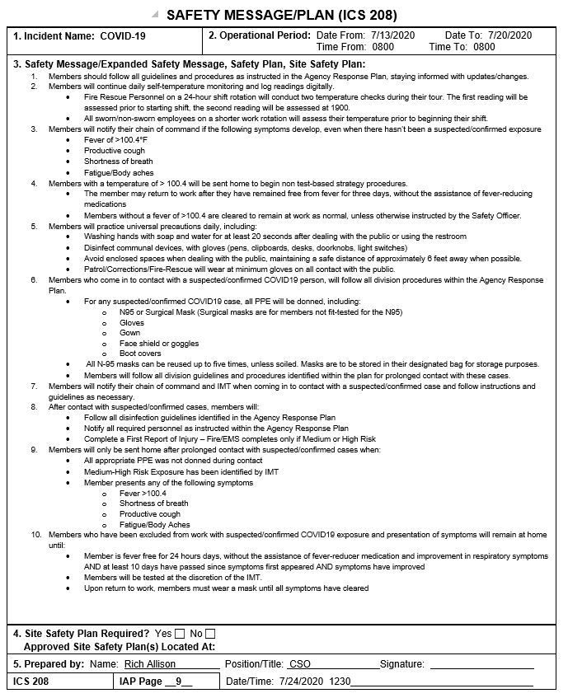



Michael A. Adkinson, Jr., Sheriff
Office of the Sheriff, Walton County
COVID-19 Pre-Arrest Screening Questionnaire

Detainee Name: _______________________________
DOB: ________________________________________
Home Address: ________________________________ _____________________________________________
Phone Number: _______________________________
Travel History
- In the past 14 days, has the detainee traveled outside of the United States? Yes No

When: ________________Where: ________________
- In the past 14 days has the detainee traveled to the following states Louisiana, Connecticut, New Jersey, and New York? Yes No
When: ________________Where: ________________
- Does the detainee report a history of traveling to or from Europe or Asia? Yes No

- In the past 14 days, has the detainee came into close contact with anyone who has traveled outside of the United States? Yes No
- Has the detainee or anyone they have been in contact with had laboratory confirmed Coronavirus? Yes No

- Does the detainee have fever, cough, shortness of breath, or other symptoms of lower respiratory illness? Yes No
Deputy Sheriff Signature: _______________________
Date: ________________________________________
If the detainee answers "YES" to questions 2, 3, 4, 5 or 6 above, immediately place a mask on him/ her and notify the WCSO Jail staff prior to beginning transport. Upon arrival, the booking detention deputy and on duty medical staff will meet in the sally port to begin the secondary screening assessment.

To be completed by the on-duty medical professional:

Temperature: _________________________________
Respirations: _________________________________
Blood Pressure: _______________________________
Oxygen Saturation: ____________________________
Medical Staff Signature: ________________________
Date:_________________________________________

Law Enforcement

And Corrections
Personal Protective Equipment Kit

PPE Kit Components
☐ Surgical Mask with face shield
☐ Gown
☐ Paper bag for mask storage
☐ Boot covers
☐ Biohazardous Bag

Biohazardous Bag
If your uniform becomes soiled with blood, vomit, or feces the deputy is to place all contaminated components of the uniform into the biohazardous bag and drop the bag at WCFR Station 12 or WCFR 4 in the designated areas,
- WCFR Station 12 / 100 Washington Street Freeport
- WCFR Station 4 / 49 South Davis Lane DeFuniak Springs
If just contact with a COVID-19 patient, regular laundering of uniforms is sufficient.

PPE Kit Indications
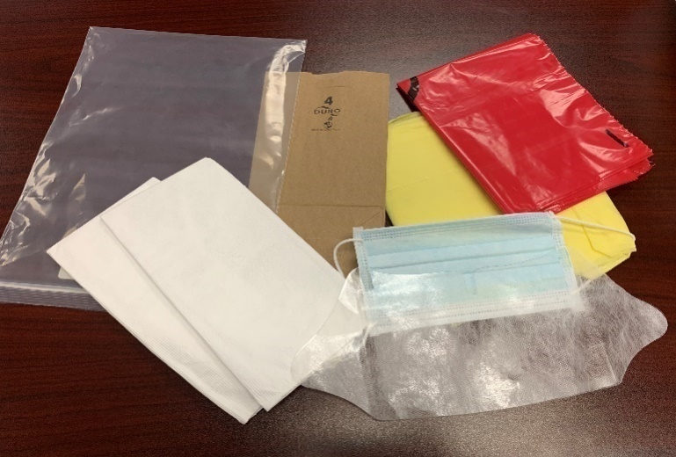
When the deputy comes into physical contact with a person who has a confirmed or suspected infection with COVID-19, all components are to be worn within the PPE kit provided including with gloves.
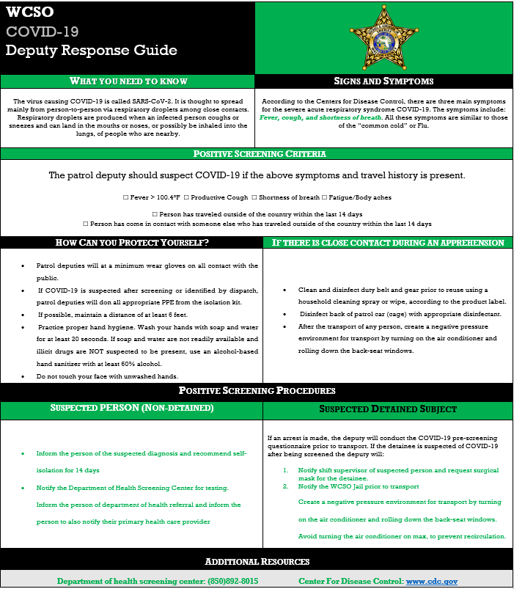

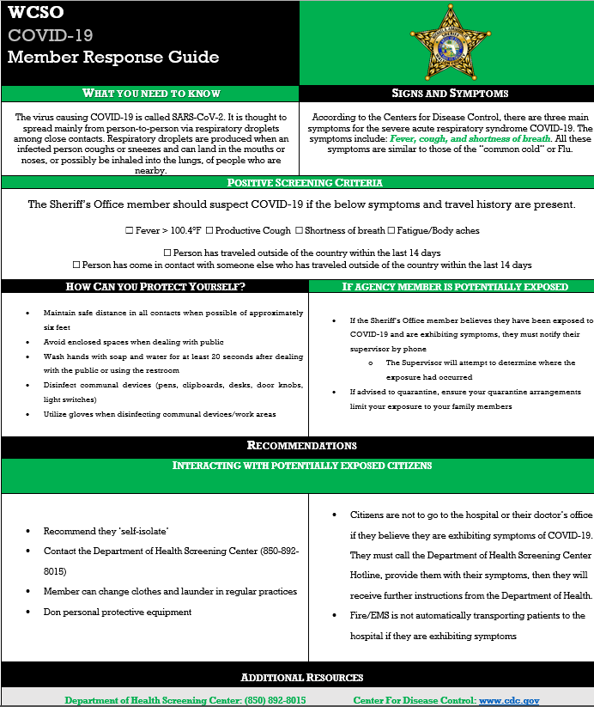

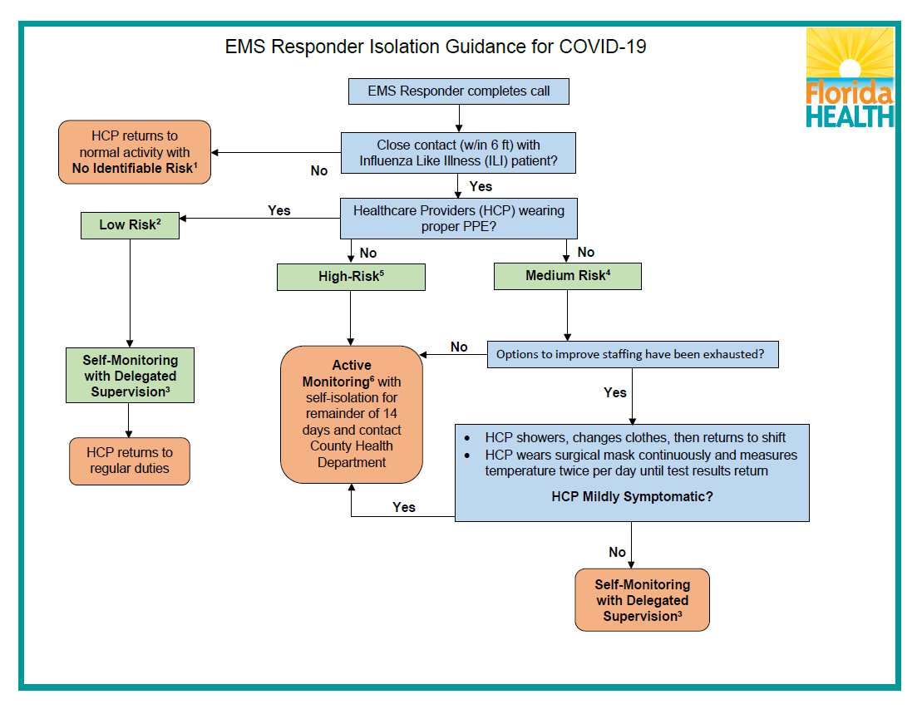

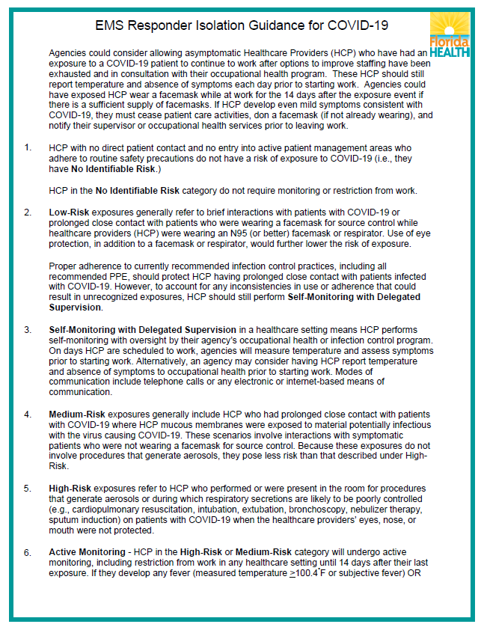

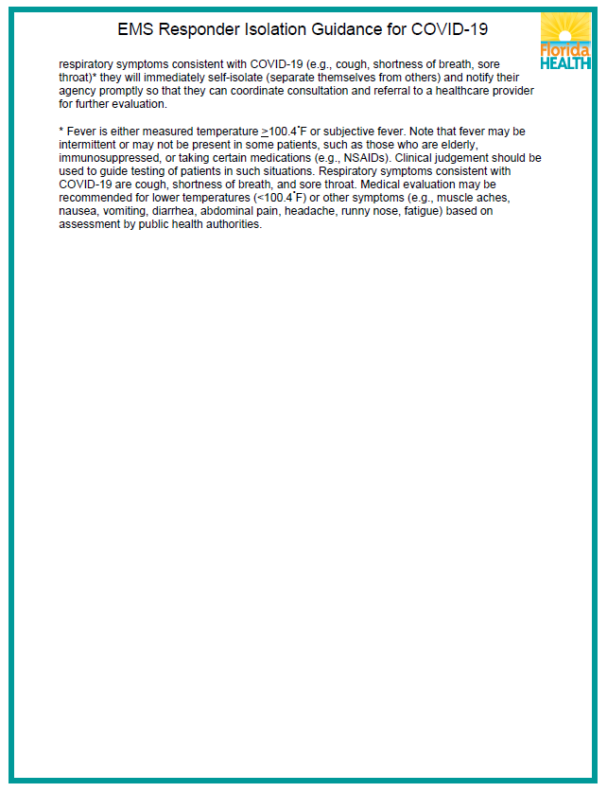

Resources
- Interim Infection Prevention and Control Recommendations for Patients with Suspected or Confirmed Coronavirus Disease 2019 (COVID-19) in Healthcare Settings https://www.cdc.gov/coronavirus/2019-ncov/infection-control/control-recommendations.html?CDC_AA_refVal=https%3A%2F%2Fwww.cdc.gov%2Fcoronavirus%2F2019-ncov%2Fhcp%2Finfection-control.html

- Interim Guidance for Emergency Medical Services (EMS) Systems and 911 Public Safety Answering Points (PSAPs) for COVID-19 in the United States

- https://www.cdc.gov/coronavirus/2019-ncov/hcp/guidance-for-ems.html

- Interim Guidance for Emergency Medical Services (EMS) Systems and 911 Public Safety Answering Points (PSAPs) for COVID-19 in the United States https://www.cdc.gov/coronavirus/2019-ncov/hcp/guidance-for-ems.html

- International Academies of Emergency Dispatch: MEDIA RELEASE: IAED CBRN FAST TRACK COMMITTEE RE: NOVEL CORONAVIRUS FROM WUHAN CITY, CHINA (2019-nCoV)

- World Health Organization: Coronavirus disease (COVID-19) outbreak
  - https://www.who.int/emergencies/diseases/novel-coronavirus-2019

Awaiting on guidance from Department of Children and Families Legal Counsel

